Dear Editor,

We are very much thankful to the editor and the three reviewers in providing positive comments and the constructive reviews. We have revised the manuscript to address the reviewers’ comments. We took every effort to provide answers and justifications for all the comments. We believe that all the comments made by reviewers have been carefully addressed and accommodated. The track changes in the manuscript are corresponding to the changes we made to the manuscript based on reviewers’ comments. The comments of the editor and the three reviews have been considered separately and provided answers for them point by point as follows.

Thank you very much.

Yours sincerely,
M.A.P. Chamikara

Responses to Editor's comments

We thank the editor for your efforts and valuable comments. Please see our responses and the track changes made in the revised manuscript.
- Put special emphasis in addressing the recommendations of reviewer 1.

Authors’ Response
Special emphasis has been laid upon the comments of Reviewer 1.

Resubmission checklist:
When resubmitting, in addition to any revised files (e.g. a clean manuscript version, figures, tables, which you will add to the "Primary Files" upload section), please also provide the following two items:
- A rebuttal Letter: A single document where you address all the Editor and reviewers' suggestions or requirements, point-by-point.
Authors’ Response
We addressed all the comments either by justifying our methods or incorporating the reviewers’ comments to our paper.
- A 'Tracked Changes' version of your manuscript: A document that shows the tracking of the revisions made to the manuscript. You can also choose to simply highlight or mark in bold the changes if you prefer.
Authors’ Response
A tracked changes version of the manuscript was submitted. The page numbers and line numbers of the modified content is provided under the author’s response (Please be kind enough to refer the “Tracked Review” version to check for the modifications).
- Accepted formats for the rebuttal letter and tracked changes document are: DOCX (preferred), DOC, or PDF.
Authors’ Response
Submitted docx versions of the rebuttal letter and the tracked changes document.
- As you previously uploaded a single manuscript file for your initial submission you will need to upload any primary high resolution image and table files separately if you have not already done so.
Authors’ Response
High resolution images and table files were uploaded separately.
- PeerJ does not offer copyediting, so please ensure that your revision is free from errors and that the English language meets our standards: uses clear and unambiguous text, is grammatically correct, and conforms to professional standards of courtesy and expression.
Authors’ Response
The paper was copyedited by a Qualified Instructor, English Teaching Unit (ELTU), University of Peradeniya. A scanned copy of the acknowledgement letter is provided herewith.

Responses to Reviewer 1

We thank the reviewer for your efforts and valuable comments. Positive comments are really appreciated. Please see our responses to the constructive comments below and the tracked changes made in the revised manuscript.

Basic reporting
- What I miss from this paper is the lack of comparison against the profiling given by humans, that is, that from the police.
Authors’ Response
The actual dataset was prepared from the solved cases where the criminal profiling was conducted by police officers in Sri Lanka Police. The data set was verified by a domain expert before being used in the analysis
- However, it is not clear how they fine-tune the fuzzy inference system. Could the authors provide more insights on this?
Authors’ Response
Thank you very much for this comment. More insight on the way the FIS was fine-tuned was newly added to Section “Building a fuzzy inference system to obtain the final similarity score” in Page 13 (Please refer the tracked changes version).
- It is also not clear how the authors labeled the classification data-set.
Authors’ Response
The classification datasets which were obtained from the UCI data repository were only subjected to preprocessing without harming their original labels unless there are intermediate levels (more than two) to a particular attribute.
For example if an attribute named ‘quality’ has three levels, the attribute is then separated to three levels, quality1, quality2, and quality3.

- One of the problems with the paper is that it is not clear whether the data used is enough so as to obtain meaningful conclusions and to be rally useful. They consider only 67 instances with 20 classes (suspects) and one can imagine that the total number of crimes is much higher. As a result, there are classes with only one instance, which are impossible to learn/predict. Does this make sense? I am not sure of that, and even if the paper makes sense the experimental part is quite weak due to these problems.

Authors’ Response
  - It should be noted that the selected 67 records are the best representative records that we could find from the available crime records at Sri Lanka Police. These records were verified by the domain experts at Sri Lanka Police.
Although the Sri Lanka police crime investigation procedure is more than 100 years old, the system is totally a manual system. There are no any methods to keep track of crimes conducted by the same criminal. Therefore, we had to conduct a very deep scraping on GCR (grave crime record) data to find the crimes conducted by each criminal. Since, there are no any methods to track the crimes, sometimes the same criminal has provided different identities. But, of course we can generate a huge dataset of classes (criminals) with single instances of crimes. But, for the validation procedure, it’s not suitable.
  - Due to these problems, we tried in deriving a suitable dataset from online databases. But none of those data repositories contain datasets similar to what we actually wanted (modus operandi datasets)
Also, the effects of the classes with single instances do not have a huge impact on the core module of our algorithm. If we further worry about our algorithm (as shown below),
- The main functionality of the proposed algorithm is to find the similarity between a crime under investigation and a criminal with a historical criminal record. As the main output of the algorithm, it generates a percentage similarity value (similarity score) which gives an insight to how much a crime and a criminal are related.
- For the evaluation of the dataset, the algorithm was then adapted to a classifier where the classification is done in the following manner.
  - Assuming 20 suspects (classes) are there, a particular crime will be classified into the class (suspect) which produces the highest similarity score.
- In our algorithm a model has already been finalized and will not be adjusted during the training process. Therefore, there will not be any negative impact from the classes with single instances on the model.
- This in turn provides a positive aspect of our method which produces unbiased results under such circumstances.
- Moreover, it is not clear how their model is applied in the rest of common data-sets. Given that it is a classification model, why not to try with a greater variety of data-sets?

Authors’ Response
This is a very good suggestion for the completeness of the paper. We have extended the experiment to compare our algorithm with six more datasets from UCI data repository. Also, we compared our method with four more classification algorithms. Namely, Sequential Minimal Optimization (SMO) algorithm, KStar instance based classifier, Best-first decision tree (BFTree) classifier, and LMT (Logistic Model Tree) classifier. The results are presented in page 26,27,28,29 and 30 (Please refer the tracked changes version). The results further justify the superiority of our algorithm over the [most of the] existing algorithms.
- As mentioned in the manuscript (in the last section of page 24 and starting section of page 25 in the tracked changes version), the proposed method can accept inputs with only categorical variables. If we want to check inputs with continuous variables, the continuous variables must first be categorized into ranges. But categorized the continuous variables into levels will make the results biased and contaminated as it needs a generalized model for the categorization.
- The datasets which we have selected here are categorical datasets where the preprocessing is only involved in introducing new levels for the attributes with more than one level. It guarantees that the base quality of the data set is not harmed by the preprocessing necessary under our method.
- The proposed method was tested for 6 more data sets which were obtained from the UCI data repository. The results are presented in page 26,27,28,29 and 30 (Please refer the tracked changes version).
- Likewise, why not to test their model against commonly used classifiers? From my point of view, this last part of the paper is poor and a superficial analysis of the results is carried out.

Authors’ Response
- The five classification algorithms used in the validation part of the original manuscript represent three different categories of classification algorithms. Those categories include, Bayes classifiers, Decision tree based classifiers and Network (function) based classifiers.
- We compared our method with four more classification algorithms. Namely, SMO, KStar, BFTree, and LMT.
- Now the method is compared against 9 other classification algorithms which represent four classes of classification algorithms. Namely, function based classifiers, Tree based classifiers, Bayesian classifiers and Lazy classifiers.
- The results are presented in page 26,27,28,29 and 30 (Please refer the tracked changes version).

- Furthermore, I would say that the statistical analysis is not properly carried out, and ranks are not properly interpreted.

Authors’ Response
We are very much thankful to this comment. We also realized the fact that the conclusions made on the results obtained by Friedman’s rank test become redundant by the Wilcoxon Signed Ranks multiple comparison test results. Therefore, we neglected the Wilcoxon Signed Ranks multiple comparison test results and made our conclusions using the Friedman’s rank test. Also, by making the ranks in the ascending order for the time and RMSE measurements, while making the ranks in the descending order for the AUC measurements, helped the process comparing the algorithms easier.
The revised statistical analysis is outlined in page 27,28,29 and 30 (Please refer the tracked changes version).

- The English of the paper should also be revised.

Authors’ Response
- The paper was revised by a qualified English Instructor of English Language Teaching Unit (ELTU), University of Peradeniya, Sri Lanka. A scanned copy of the letter of acknowledgment is provided below.

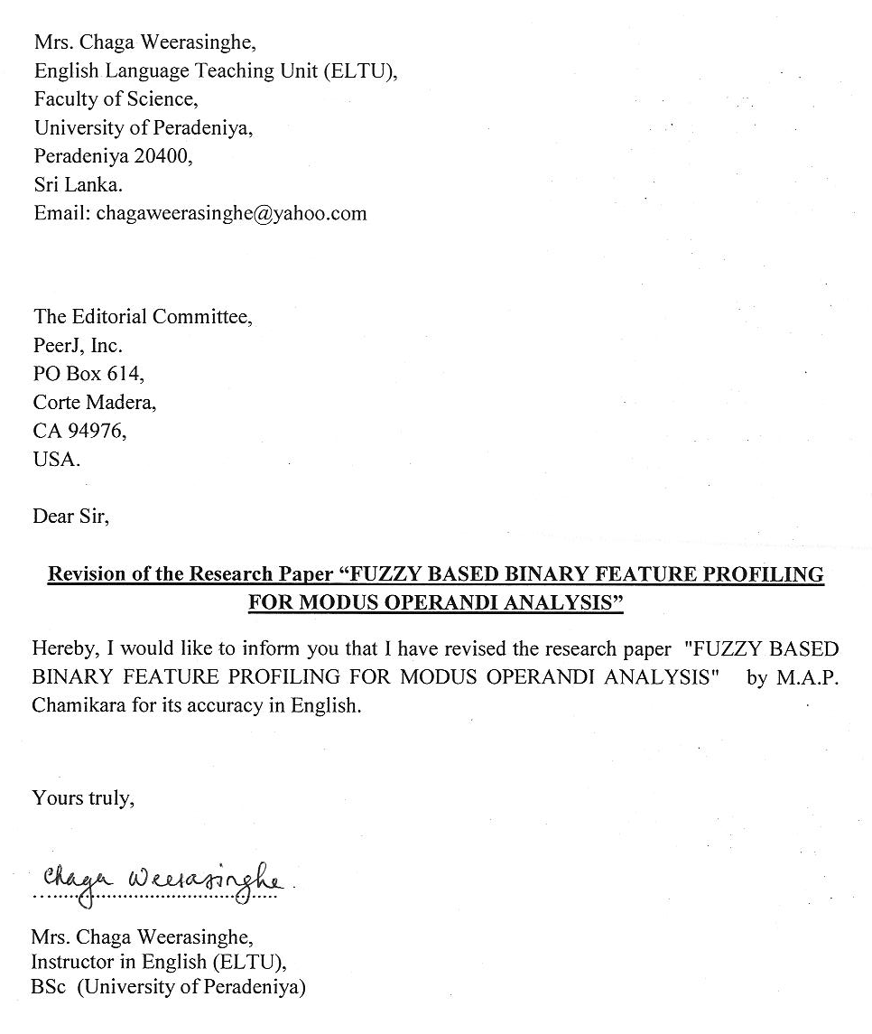

Experimental design
- The authors data may be meaningless so as to achieve meaningful conclusions. The experimental framework and analysis of UCI data-sets is not properly carried out and the statistical tests are misinterpreted.

Authors’ Response
As mentioned under the authors’ responses to comment 5, 6 and 7, we extended the analysis of our model against 6 more UCI data sets and the newly proposed method was compared with 4 more classification algorithms. The conclusions were then altered accordingly based on the new results. Statistical analysis was also revised based on the suggestion made in the comment 7.

Validity of the findings
- I am not sure of the real validity of their findings due to the low number of instances considered (67, with some classes having only 1 instance).

Authors’ Response
Due to the aforementioned constraints in the authors’ response to comment 4, we had problems in extracting a considerable number of instances. However, the selected 67 instances were representative crime records of the manual crime records available at Sri Lanka Police. These 67 instances were selected under the supervision of a domain expert at the Sri Lanka Police. Therefore, we tried to validate our method in two aspects. We first validated our method against the 67 instances we extracted. Then we tried to validate our method by adapting it to a classification algorithm and comparing the classification efficiency against nine other well established classification algorithms.

Responses to Reviewer 2

We thank the reviewer for your efforts and valuable comments. We are very much thankful for the positive comments. Please see our responses for the constructive comments below and the track changes made in the revised manuscript.
- Section "Related work": -
- clearly separate (in several paragraphs) data mining techniques: Association rules , Link analysis, Classification

Authors’ Response
It is a good suggestion to separate this content into paragraphs for the clarity of the paper. Paragraphs were divided accordingly as proposed here. Please refer page 4,5 and 6 (Please refer the tracked changes version).

- mention in particularly the distance metrics between binary vectors proposed in the literature and cite them when introducing DP and CP

Authors’ Response
We have paid particular attention about other binary vector measurements and cited them. Please see page 12 in tracked changes version.

- Rows 196-197: replace "materials" with "systems"

Authors’ Response
We have incorporated the changes to the paper in page 6 of the tracked changes version.

- Section "Generating the dynamic MOs.." :
- if DMO is related to a particular criminal, then replace in row 292 "second criminal" with "same criminal"

Authors’ Response
Thank you very much for noticing this error. That part was corrected in first part of page 10 in the tracked changes version.

- no need of equation (2) - it's sufficient to mention that M_D is the median of D sequence

Authors’ Response
Changes have been incorporated to the paper in page 10 of the tracked changes version.

- Section "Finding deviation ...":
- change in Eq (6) "x_i - y_i" with (x_i = ) AND (y_i = 0)
- row 350 - there is no table 7 here
- row 355 - replace "Equation" with "expression"

Authors’ Response
Changes have been incorporated to the paper in page 12 of the tracked changes version.

- Sometimes the information is repeated, as in the rows 549 - 552.

Authors’ Response
Thank you very much for noticing repeated content. We reviewed the content and made necessary corrections in the places where repeated content was there.
Examples: page 12, 13, 16, 21, 25, and 30 of the tracked changes version.

Experimental design
No comments

Validity of the findings
No comments

Comments for the author
- Re-read carefully the text. Sometimes the predicate is missing.

Authors’ Response
We reviewed the content and made necessary corrections in the places where the predicate was missing. The paper was revised by a qualified English Instructor of English Language Teaching Unit (ELTU), University of Peradeniya, Sri Lanka. A scanned copy of the letter of acknowledgment is provided above.

Responses to Reviewer 3

We thank the reviewer for your efforts and valuable comments. We highly appreciate the positive comments. Please see our responses for the constructive comments below and the track changes made in the revised manuscript.

Basic reporting
- The bibliography must be updated, only one submitted reference in 2015 is referenced. Most of references are to dates earlier than 2011. Reference 49 must include the year of publication.

Authors’ Response
Thank you for the suggestion. Year of reference 49 was updated. More publications from Examples: References [13], [15], [17].

Experimental design
No comments

Validity of the findings
No comments

