Professor Hutchinson,

Thank you for taking the time to administer the review of our paper with PeerJ. We were very pleased with the quality of the reviews, and have done our best to implement reviewer suggestions, especially with respect to clarifying the distinction between sprawling/parasagittal and crouching/upright postures.

We feel that the manuscript has improved as the result of these edits, and hope that you are satisfied that the new version of the paper meets the criteria necessary for publication in PeerJ.

We are amenable to most of the reviewer suggestions, however, Reviewer 1 suggests amending the paper to include an analysis of %Recovery – comparing oscillations in the E_{K} and E_{P} of the COM to determine whether the body’s movements are run-like, or walk-like, based on the phase relationships of E_{K} and E_{P} (of course, you’re very familiar with analyses of this kind). We push back, arguing that measuring %Recovery for shrews and voles probably doesn’t really tell us anything about the mechanics of how they move. As you will see, we have actually completed the entire analysis that Reviewer 1 requests, and included it in our response, but for the reasons we argue in our response to Reviewer 1, feel that the paper is stronger without the %Recovery analysis included. We hope as editor, you will agree.

Our responses to all reviewer comments are itemized below.

Many thanks,

Dan Riskin
Corinne Kendall
John Hermanson

Reviewer 1:

Comment: “Line 80-81: “side-to-side’ suggests lateral…..I think you need to reword here to better state that you mean fore-aft (i.e. crouched posture required more fore-aft force because the GRF vector is more horizontally oriented)”

We actually do mean mediolateral, not fore-aft, so we leave the text as it is.

Comment: “84-85: I find it very odd that a vole can be classified as having an upright posture. I think the authors really need to give some definitions, based on quantitative metrics, of what postures defines crouched vs. upright…..there are probably such data on a handful of species in the literature. By compiling such data, perhaps they could better show that the vole is indeed ‘upright’ or that it is actually crouched, just less so (as compared to an ungulate which is truly upright).”

We appreciate this helpful comment. We certainly agree with Reviewer 1 that voles are not at the extreme upright end spectrum among modern mammals. Indeed, voles come nowhere near the posture of a bovid, for example.

The best index of posture that has been quantified among mammalian species is Biewener’s “Effective mechanical advantage” (EMA; Biewener 1989; 2005). The strongest predictor of EMA is body size, with larger mammals having higher EMA values than small mammals (Biewener 1989; Fig. 2).
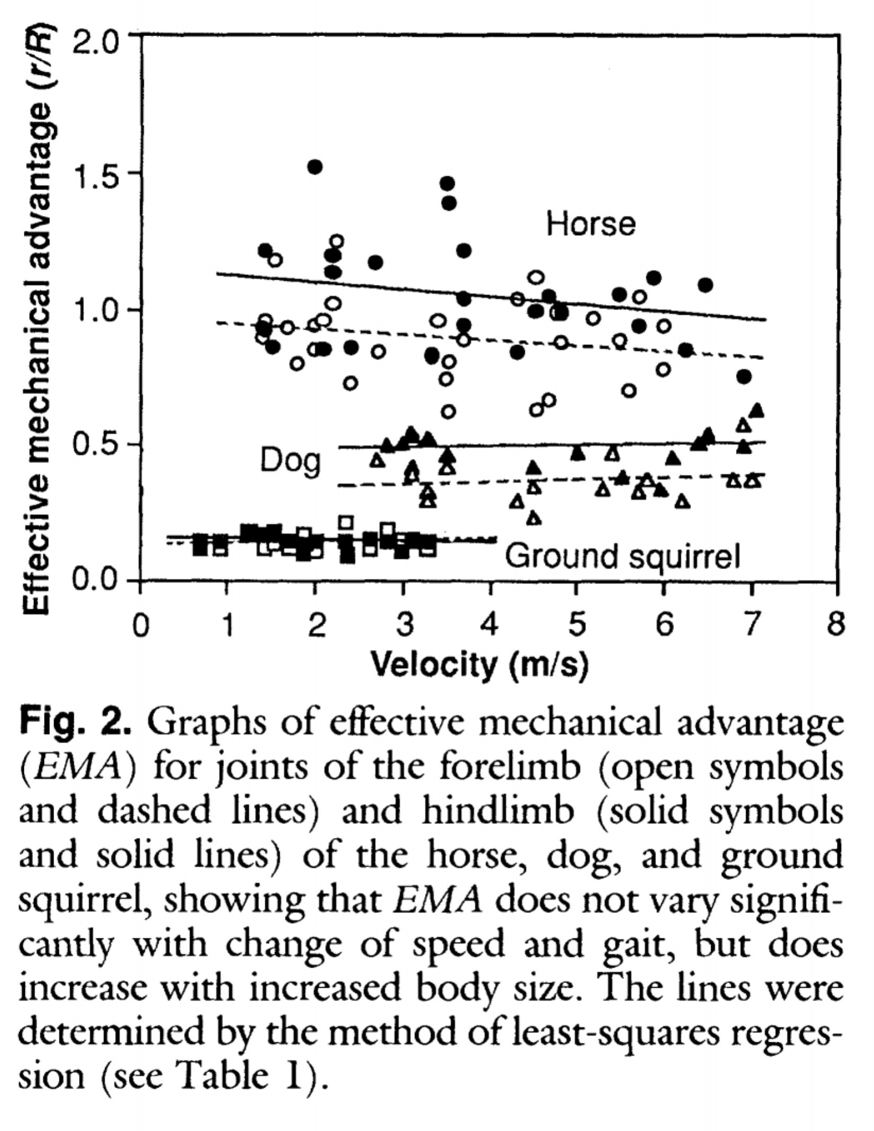
To be sure our animals fit the pattern described above, we measured EMA from the animals in Figure 1 of our manuscript, for a representative EMA from a shrew and a vole. Their EMA values (forelimb and hindlimb of both species ~0.2 to 0.3) are well within the scatter for animals of similar size in the Biewener plot above. In other words, the mammals in our study are about as crouched as they should be for a mammal of their size. However, we have left EMA out of the manuscript itself, since we did not measure it across trials.

Shrews and voles are both small, so, as Reviewer 1 points out, neither stands upright, compared with horses in the figure above, or indeed other large mammals. We have therefore modified the manuscript to be more careful throughout to say only that voles have a more upright posture than shrews do.

We have also added the following text to the paragraph in question to address Reviewer 1’s comment:

“Since we are interested in the evolution of early mammals, which were small, our study does not include large mammals, which possess much more upright postures than any small mammals do (Biewener 1989; 2005). As such, we do not investigate the full range of postures present among modern mammals, but instead focus on two species that serve as a proxy for the kind of variability that existed when mammals first diversified.”

Comment: “94-95: so based on what I think your argument is saying at lines 80-81, you might also include fore-aft forces as part of this cost.”

This comment may have arisen due to the confusion at line 80-81, which we address in our first response (above). However, it does bring up the important question of whether or not we should raise the issue of fore-aft forces in the introduction.

After careful consideration, we ultimately decided not to include hypotheses about fore-aft forces in the introduction. Our concern is that by doing so, we would confuse the reader about the central hypothesis being tested. The hypothesis around which we designed our experiment concerns the magnitudes of laterally directed forces, not fore-aft ones. However, since the data we uncover make clear the importance of accelerations and decelerations in the direction of travel to these animals, we expand on those phenomena in the discussion. We hope that Reviewer 1 will be satisfied that the inclusion of fore-aft forces in the results and discussion addresses their concern.

Comment: “122: ‘walked’ were the animals walking or running? Better to say, moved across the plate. Walking and running have specific definitions. You actually have all the data you would need to compute the phase shift of the KE and PE and also percent recovery from pendular mechanics. Based on your sample traces, it looks like KE and PE are in-phase and thus the animals are running. Also, what about comparing the magnitude of the KE and PE to get a sense of whether these animals are more cursorial or more lumbering? See: Biknevicius, A.R., Reilly, S.M., McElroy, E.J., and Bennett, M.B. 2013. Symmetrical gaits and center of mass mechanics in small bodied, primitive mammals. Zoology. 116:67-74 AND Reilly, S.M., E.J. McElroy, R.A. Odum, V.A. Hornyak. 2006. Tuataras and salamanders show that walking and running mechanics are ancient features of tetrapod locomotion. Proceedings of Royal Society of London B. 273: 1563-1568”

We agree that “moving” is a much more appropriate word than “walking,” since it takes us away from a number of assumptions. We have made that change at line 122, as suggested, and similar changes throughout the manuscript.

Reviewer 1 is absolutely correct about our ability to calculate E_{K} and E_{P} phase shifts based on these data. We actually included analyses of those parameters in earlier drafts of the manuscript.

To quantify the capacity for pendulum-like exchange between E_{K} and E_{P} of the COM within a stride, we calculated percent congruity (%Congruity) - the percentage of time taken to complete the stride cycle for which E_{K} and E_{P} increase together or decrease together, to the exclusion of time where the product of their slopes is negative – and also Percent recovery (%Recovery), calculated as
.
Values for %Congruity for shrews were 57.4 ± 7.2% (mean ± S.D.), and for voles were 60.7 ± 4.0%. Values of %Recovery for shrews were 21.2 ± 8.4%, and for voles were 21.1 ± 2.8%. We did not observe significant differences in %Congruity (two-tailed t = 0.86, P = 0.42) nor %Recovery (two-tailed t = 0.007, P = 0.99) between species. Percent Recovery values did not change significantly with increasing speed for either species (shrews: F = 0.49, P = 0.50; voles: F = 0.45, P = 0.51).

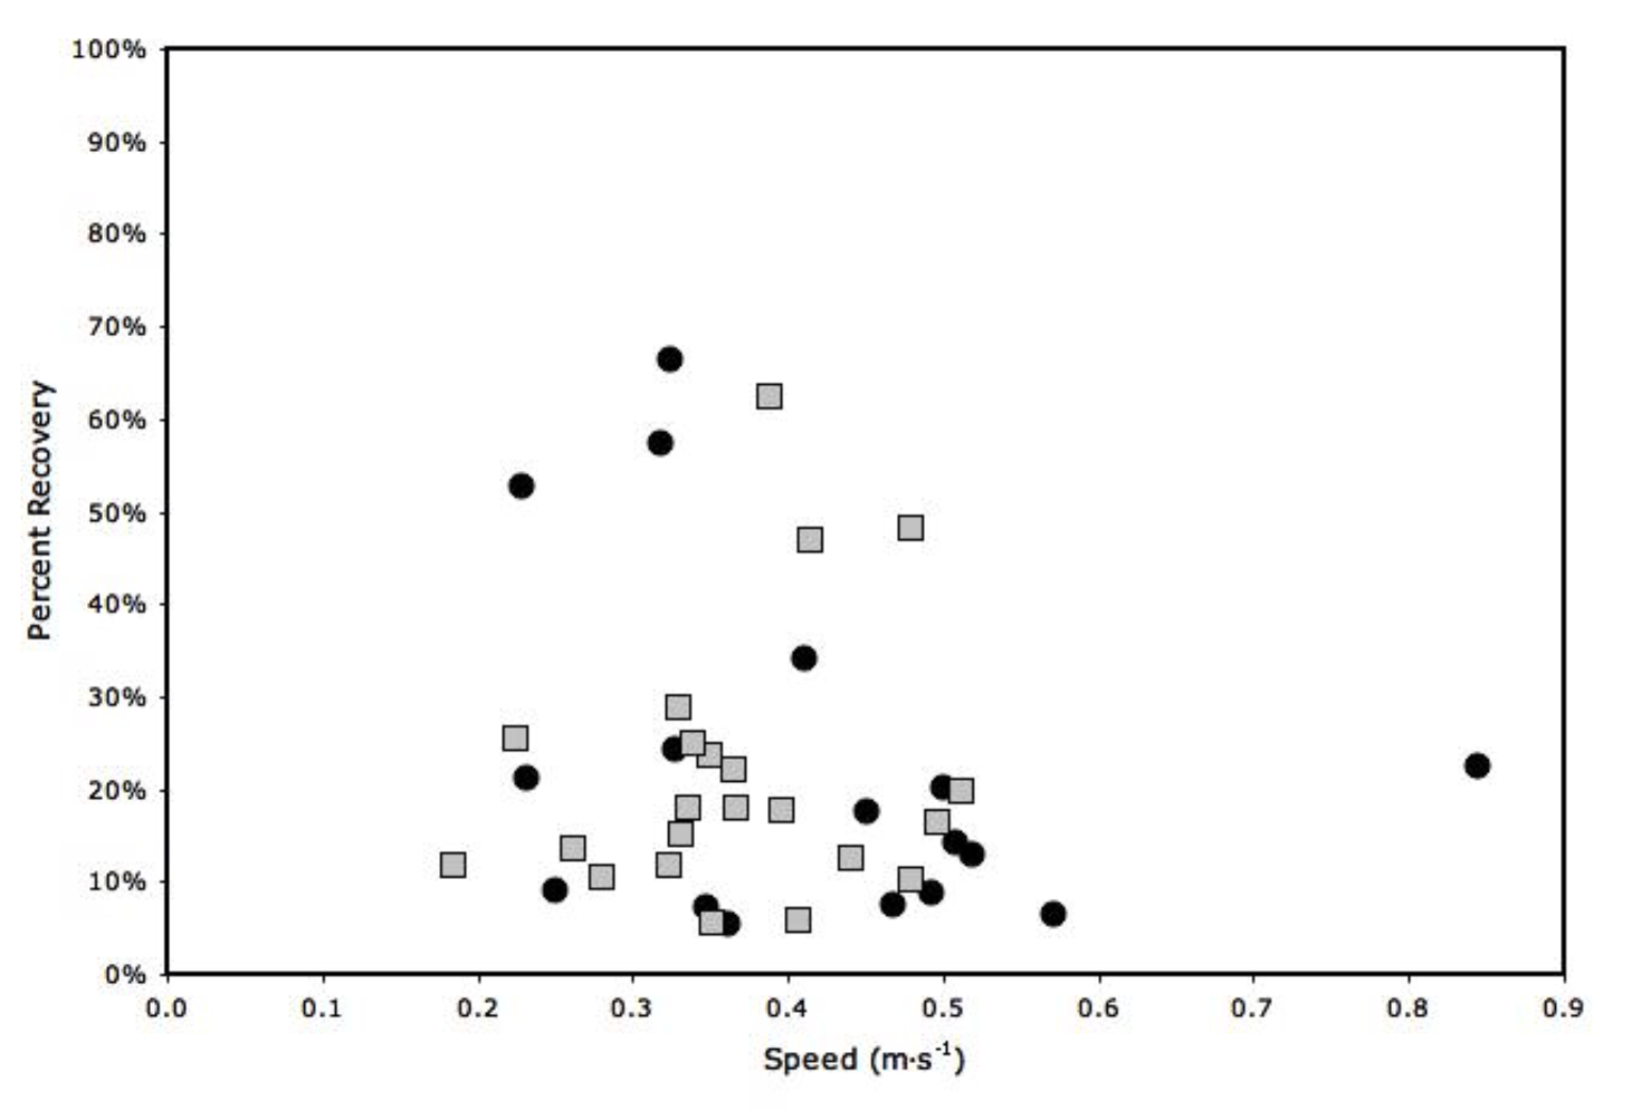
Percent recovery values neither increased nor decreased with speed for either species. %Recovery did not differ between shrews (black circles) and voles (grey rectangles).

In earlier drafts we included %Recovery and %Congruity in the manuscript, and took the lack of a significant difference between species as support for the hypothesis that differences in pendular mechanics were not an important selective pressure shaping changes in posture in early mammals.

Although these analyses were included in earlier drafts, we ultimately decided to drop them from the manuscript before submission to PeerJ. When we had shown those manuscripts to colleagues, many were distracted from the central conclusions of our paper by the %Recovery and %Congruity story. Several reviewers questioned the relevance of pendular energy saving mechanisms to mammals as small as those in this study. Others argued that while pendular mechanics have been inferred as an important mechanism of energy savings, a detailed accounting of how they would work for a quadrupedal mammal has not been presented. They went on to point out that more recent work, especially by Bertram and Ruina and others, suggests that pendular mechanics might not be as relevant to energy savings in quadrupeds as the reduction of collisions (Bertram, Ruina, and Srinivasan, 2005. J. Theor Biol 237: 170-192). Ultimately, those reviewer comments motivated us to take that portion of the story out of our paper. We failed to disprove the hypothesis that there were differences between species, and we failed to disprove the hypothesis that %Recovery changed with speed. There may be a pendular mechanics story to be told in the locomotion of shrews and voles (indeed, we have reported on COM E_{K} and E_{P} mechanics for small crawling bats previously; Riskin et al., 2006. J. Exp. Biol. 209, 1725-1736.), but we didn’t feel this paper had sufficiently meaningful data to defend such an analysis.

Comment: “190-203: It seems like there should be more details about the data and statistical comparisons. Means and S.D? Statistical comparisons of these means? I think you need this to say the postures are (or are not) different.”

From our observations of animals walking across the force plates, captured in lateral and dorsal views with high-speed cameras, we came to the conclusion summarized in the first sentence of our results, that “the postures of shrews were more crouched than those of voles.” This was visible as the belly of a shrew being right against the floor, whereas the belly of a vole was held above. However, we were unable to see the precise orientation of the limbs from those videos.

Thus, after the force-plate/high-speed video trials were complete, we used two shrews and three voles (not used in the other part of the study) to collect joint angle data from radiographs of the limbs during locomotion. The x-ray set up did not permit us to quantify speed at the same time as radiographs were taken, but from the image sequences collected, we were able to quantify the range of joint angles. Our x-ray data, therefore, unlike our force plate data, are too limited for rigorous statistical comparisons between species. We use them simply for descriptive purposes.

Comment: “133: Was the 50% window needed because these animals rarely moved at steady speed? Is this a key feature of their locomotion? I understand the need to delineate the used trials due to the steady speed assumptions of some of the biomechanics analyses…..however, the reality for these animals might be that they rarely move at a steady speed……so why not include these as part of your data (i.e. we ran the animals xxxx times and only xxx trials fit our criteria for steady speed.”

We are grateful to reviewer 1 for this comment, which touches on issues also raised by Reviewer 2. We have thus made changes to the methods, results, and discussion sections to address the 50% cut-off, and feel our paper is improved by those changes.

We infer from Reviewer 1’s comments that our phrasing around the 50% cutoff of Ahn et al. (2004) created the misunderstanding that we had cut off a distribution of percent-speed-changes, to gather only the lower portion of that distribution. However, this was not our methodology. We simply discarded trials in which the animal came to a complete stop and then started walking again in the middle of a stride cycle. We did not know that the we had met Ahn et al.’s 50% criterion until after analyses.

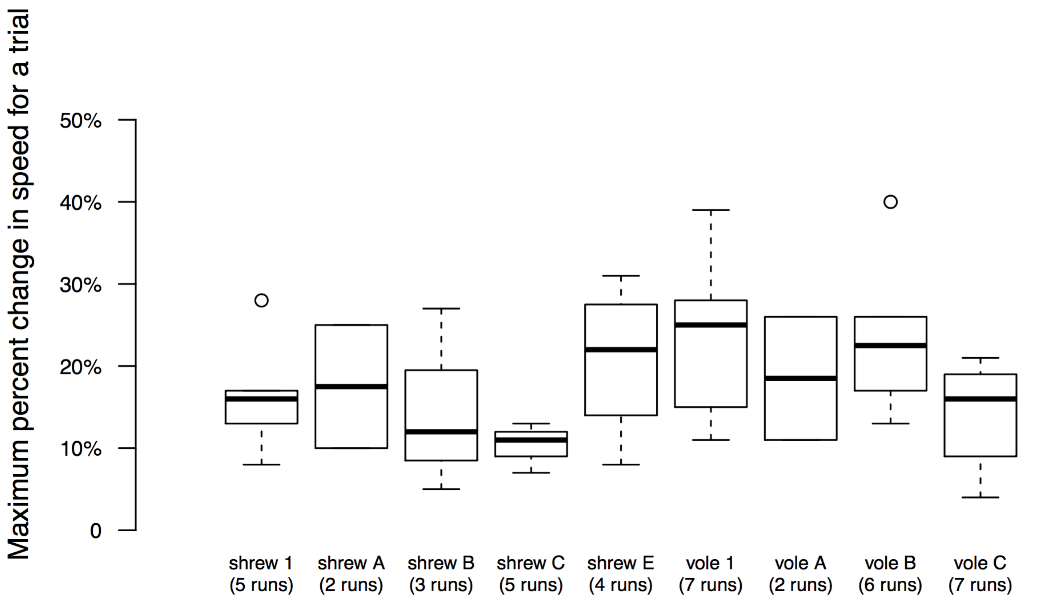
Note that the percent speed changes are roughly bell-curved for all individuals, and are not truncated by an experimentally imposed upper limit of 50%.

In the methods, we have now reported the distribution of percent speed changes, to say that the data in our paper meet that criterion, not that we molded our data to fit that description. We have rephrased the paper to make it clear that what we discarded were those trials where an animal came to a full stop, removing all mentions of the 50% cut-off.

Comment: “209: report DF for the t-test” & “201: report numerator and denominator DF for the linear models.”

We have added those details to the results section, and included analogous statistical details for the other stats tests in the paper.

Comment: “212-222: there are specific conditions for using 1 vs. 2 tailed test. You need to justify the use of a one-tailed test if you are going to use it! This is particularly relevant for your results, as most one-tailed p-values you report would not be significant if they were two tailed p-values.”

We use one-tailed tests where we had a priori assumptions about the direction a difference would have. We expected shrews to have larger lateral forces than voles (not just different), and we expected that mass-corrected energy consumption would be higher for shrews than voles. Because we didn’t have a priori assumptions about which species would be faster, nor which would have greater changes in speed, we use two-tailed tests there.

Comment: “Results: could any of the mechanical data (force, energy, power) be impacted by speed. I realize that the t-test showed that the two species ran similar speeds….however, there may still be a speed effect on total mechanical power and if so, you might expect that shrews would show larger force, energy, power because they ran slightly (albeit non-significantly) faster. Can you also correct for speed like you corrected for mass, such that power is in watts per kilogram-meter (adjusted for speed and mass)”

This is an interesting hypothesis.

Here, we present 12 linear models, 6 per species, testing the effect of speed on each of the six power measures, using “individual” as a random effect. Significant effects (P<0.05) are in bold. All significant correlations are positive.

 | shrew | Vole
P_{ETOT} | F(5,11) = 3.38, P=0.04 | F(4,17) = 1.63, P=0.21
P_{EP} | F(5,11) = 4.63, P=0.02 | F(4,17) = 3.53, P=0.03
P_{EK} | F(5,11) = 3.61, P=0.04 | F(4,17) = 0.42, P=0.78
P_{EKF} | F(5,11) = 4.07, P=0.02 | F(4,17) = 0.41, P=0.79
P_{EKL} | F(5,11) = 2.97, P=0.06 | F(4,17) = 2.57, P=0.07
P_{EKV} | F(5,11) = 9.70, P=0.0009 | F(4,17) = 1.41, P=0.27

These data demonstrate that P_{EP} increases with speed for both species, and that for shrews, P_{EK} increases with speed, mostly because of changes in P_{EKF} and P_{EKV}.

We find it interesting that shrews show correlations not present for voles; this may underscore some fundamental differences in the mechanics of locomotion between these species. However, with respect to Reviewer 1’s hypothesis that differences in speed across trials might be driving interspecies differences, we do not find support in these data. Note that P_{EP} is the only factor that increases with speed for both species, and there was no significant difference in P_{EP} between species.

Importantly, we have not attempted to correct for body size, and it’s possible that once Froude Number is taken into account, that shrews are moving more quickly than voles by a significant amount. However, in the scope of this study, speeds are overlapping to such a significant degree that we do not think that differences in power (P_{ETOT}, P_{EK}, P_{EKF}, P_{EKL}) between species are driven by differences in speed.

Comment: “224: Again, I am not convinced that you can really call a vole ‘upright’, a least not like you would refer to a horse as upright. I think you are likely really looking a variation within a range of crouched postures.”

We have made changes throughout the manuscript that we hope will alleviate this concern.

Comment: “231: side-to-side instead of ‘back and forth’”

Great comment. Done.

Comment: “238-239: Reword the sentence beginning “These results” I would avoid saying ‘we overestimated’ and instead more simply say that the lateral forces were less important for the overall mechanical power. ”

Done.

Comment: “241: again, I am not sold on calling a vole ‘upright’!”

Fixed.

Comment: “260: however, they could be mechanically distinguishable based on phase-shifts between the KE and PE….I suggest adding this analysis.”

In our responses to comment 4 (above), we show a graph of %Recovery vs. speed that demonstrates that even by the E_{K}-E_{P} oscillation descriptor of gait, there is no distinguishable gait change with speed. We have chosen to leave %Recovery analyses out of the paper for the reasons outlined in that same response.

Comment: “265: not vaulting, but spring recovery from tendons. Vaulting refers to holding the leg rigid and moving the COM over it …also called walking or pendulum mechanics.”

Reviewer 1 is absolutely correct. We have made the change.

Comment: “270: what about rapid acceleration? From a crouched posture an animal is ready to ‘jump’ into running (or just jump!) whereas an upright animal typically has to counter-move first. This would give crouched animals an advantage of more rapidly accelerating. I don’t have a reference off the top of my head for this (and there may not be one comparing crouched or sprawling to erect animals)…..but it seems likely and could be posited as an additional hypothesis for the advantage of crouchedness.”

Excellent insight. Added.

Reviewer 2:

Comment: “Basic reporting:

“Professional English language was used throughout the manuscript. The introduction informs the reader of the context (the postural changes during mammalian evolution). The authors make clear that the current manuscript is not focused on the shift from a sprawling to a parasagittal limb orientation, but on a secondary trend within mammals towards a more erect limb posture. I like this differentiation, because in the literature this is often lumped together simply as the sprawling-to-erect paradigm and usually the secondary component is not getting enough attention. I was a little confused to see that the authors apparently still link the reduced magnitude of laterally directed ground reaction forces to this secondary component (e.g. line 56-60). To my understanding the change in the magnitude of laterally directed GRFs is linked to the primary shift from sprawling to parasagittal. This is also stated later by the authors (lines 64-69). For example, the authors should consider exchanging the somewhat unclear word “upright” with “parasagittal” in line 56 to clarify. The structure conforms to the PeerJ standard. All figures are relevant and of high quality. Labeling could also include the individual unless better justification for pooling data is provided (see below). Raw data is provided.”

We thank reviewer 2 for these kind comments about the study’s overall reporting. We have adjusted the language around lines 56-60 as suggested.

Comment: “Experimental design…

The study presents original primary research within the scope of PeerJ. The research question is well defined and meaningful (but see my comment on clarifying the abstract below). The investigation is performed to a high technical and ethical standard. The methods are described with sufficient detail to replicate.”

“Validity of the findings…

“For the most part, the data is robust (but see my comment on pooling data below), statistically sound and controlled. The conclusion is linked to the original research question. All speculation is identified as such.”

We are obviously very pleased with these comments about our experimental design and the validity of the findings.

Comment: “Abstract: Please consider to re-word lines 18-24 to clarify that here not the consequences of a change from sprawling to parasagittal limb orientation are studied, but from crouched to erect. In a crouched posture the limbs are not oriented downward (line 20) and a crouched posture is not upright. This should be disentangled.”

We have modified the abstract for clarity.

Comment: “Line 56: Please consider exchanging “modern” with “cursorial”.”

Done

Comment: “Line 66: Note that experimental data on sprawling animals show that the GRF not always points towards the animals CoM, but instead usually the medio-lateral force is <10° from vertical (cf. e.g. Chen et al 2006 JEB; Kawano and Blob 2013 Int Comp Biol, Nyakatura et al 2014 Evol Biol).”

The papers suggested here by Reviewer 2 were extremely helpful, especially the data presented by Chen et al. about locomotion in geckos. Chen et al. show that lateral forces are even larger than fore-aft ones for running (sprawling) geckos. Those data, combined with the relative unimportance of mediolateral forces in the mammals we study, suggest that in the mammalian evolution from (1) sprawling, to (2) crouched & parasagittal, to (3) upright & parasagittal, mediolateral forces become smaller at the first of those two transitional steps. That has motivated changes to the discussion and abstract.

We looked carefully at Kawano and Blob’s statement that across taxa, GRFs are <10˚ from vertical, and have come to doubt just how widespread that trend truly is. Chen et al. (2006) show mediolateral forces 26.2˚ ± 16.3˚ from vertical in the forelimbs, and 39.1˚ ± 12.6˚ in the hindlimbs in geckos (Table 2 & Figure 8B). Nykatura et al.’s peak medial GRFs are 25% the magnitude of vertical ones, implying peak angles of at least 14˚ from vertical (or even higher angles if the peaks of medial and vertical forces do not coincide in time). And indeed, while Kawano and Blob’s data do fit the <10˚ pattern, they only do so for about half the stride cycle. (See their Fig. 2 bottom right panel, dotted line). While the time at which angles are <10˚ coincides with peak vertical forces (~25% to 75% stance phase), it does not coincide with the timing of peak medial forces (~10-20% stance phase; Fig 2 middle row, right side, dotted line).

However, with that said, in following up on these papers, we found little support for our hypothesis that GRFs are oriented directly toward the COM, and therefore make changes to the introduction accordingly.

Comment: “Line 69: The sentence starting with “Because…” is presented as a fact. There should be a citation.”

Good catch. This is a hypothesis, and is rephrased as such.

Comment: “Lines 128-135: Justification for pooling data. Given the relatively small sample size (17 and 22 trials, respectively) what was the justification for pooling the data for each species? How many trials of each individual were used? Did the individuals of a species differ significantly from each other? I suppose this was not the case, but was the sample size even big enough to even test this? A table presenting these data would help the reader to better understand the data basis of the study.”

We have added a table to the study (Table 1) to make more of this information available to the reader, and explain our statistical methodology below.

When a single animal performs multiple trials, those trials cannot be treated as independent measures for the species. For t-tests, all trials for each individual were averaged, and one number was taken from each individual for testing. This reduced our sample sizes from 17 shrew trials and 22 vole trials to 5 shrews and 4 voles, respectively. This is what we attempted to explain at line 184, which seems to have created confusion, as reflected by the comment below (“Line 184: Where are…”).

There is however, an exception to this, and that is the t-test comparing shrew speeds with vole speeds. In that case, we are not seeking to uncover true differences in the populations of shrews and voles in preferred speeds on a force platform. Instead, we sought to know whether the speeds we sampled in our study were similar enough to warrant the comparisons we make between species. We therefore argue the treatment of each trial as an independent observation for that statistical test is appropriate. Also, since we want to make sure there is no difference in speed, having a little too much power and still not finding a difference is reassuring (compared with being conservative about power, finding no difference, and wondering whether we just failed to uncover a difference because of small DFs).

For regressions we treated individuals as random effects. This methodology seeks the best slope to describe the data, but allowing each individual to have a different intercept, to correct for within individual covariance (Riskin et al., 2010).

Comment: “Line 134: Instantaneous deviation of up to 50% from average speed was accepted to include trials for further evaluation. This appears to be quite far from an ideal steady-state trial. Deviation from steady state should have enormous impact on center of mass energetics and hence locomotor costs. How much did the individual trials depart from perfect steady-state? Again, a table would help to better understand the data basis of the study.”

Reviewer 1 brought this point up as well. We have therefore adjusted the methods and results to omit any mention of the 50% cutoff, and make our overall methods clearer.

We simply threw out trials in which animals came to a complete stop mid-stride cycle, and then resumed walking.

Actual changes in speed over the course of a stride cycle (reported in the results) are 16% ± 3.9% for shrews and 19.8% ±4.5% for voles. We have presented values for each individual as a boxplot in a figure as part of our response to Reviewer 1. It’s clear from that figure that the pattern is similar across individuals.

Comment: “Line 138: A different set of animals was used to “verify” the difference of posture. How did these animals compare to the ones used for the GRF measurements? Were they of the same size and mass?”

We have modified the methods section to now include the body masses of x-rayed individuals, which overlap with those of animals in the force plate part of the study.

The fluoroscopy system did not permit accurate three-dimensional quantification of animal velocities nor precise quantification of joint angles mid-stride (one angle of view, 8 Hz frame rate).

Since we state in the paper that shrews crouch more than voles do, the x-rays were taken simply to demonstrate that what we were saying can be seen; to show our readers that that shrews crouch more while standing than voles do. We now include original x-rays in Fig. 1 to make that even more clear.

Comment: “Line 142: Why not show a fluoroscopic image to visualize the difference in posture? I believe an objective image will be more convincing than the line drawing (fig. 1).”

We have added the fluoroscopic image to Figure 1.

Comment: “Line 168: The sentence starting with “Mediolateral…” is unclear. I get it, but certainly mediolateral kinetic energy was not calculated in the same manner as fore-aft kinetic energy (you need mediolateral velocity).”

Change made.

Comment: “Line 184: Where are these data? What is the mean of each individual?”

We have added a table to the paper (Table 1), which we hope will address this concern.

Comment: “Line 193: Please provide more precise data. What was the difference in (mean) humeral and femoral orientation at a) touch down, b) mid-contact, and c) lift off? At what speeds were these measurements made? What are the differences between individuals? This would allow the reader to judge about the posture between both species.”

At 8 Hz, we were not comfortable measuring joint angles at foot touchdown, mid-stance, nor at lift-off, simply because there was too much movement in between frames. We were primarily interested in how the animal carried its core body as the limbs conveyed it forward. We could see the relatively more upright (off the substrate) manner in which the body was held in the voles as compared to the shrews (the ventral surface of the animal was held relatively close to the substrate). We agree that it would be nice to have higher speed video of the animals in motion, but, that was not possible with the equipment to which we had access at the time. Future studies, for example, could employ XROMM to gather the kinds of data described by Reviewer 2.

Comment: “Line 210: This result is probably just an artifact of limited sample size. In most animals studied so far stride frequency converges to a certain value.”

Stride frequency has been shown to increase with speed for a wide range of animals (Heglund & Taylor, 1988. J. Exp. Biol. 138, 301–318; Taylor, Heglund, & Maloiy. 1982. J. Exp. Biol. 97, 1–21; Bertram and Ruina. 2001. J Theor Biol. 209: 445-453.). The pattern we show for shrews and voles in this study mimics that widespread pattern.

Comment: “Line 228: This result/interpretation really hinges on the assumption of a steady-state gait in both species (see above).”

We agree with this point, and have removed mention of level ground, accordingly.

